FLOW CHART OF the POCSO Act and Punishments
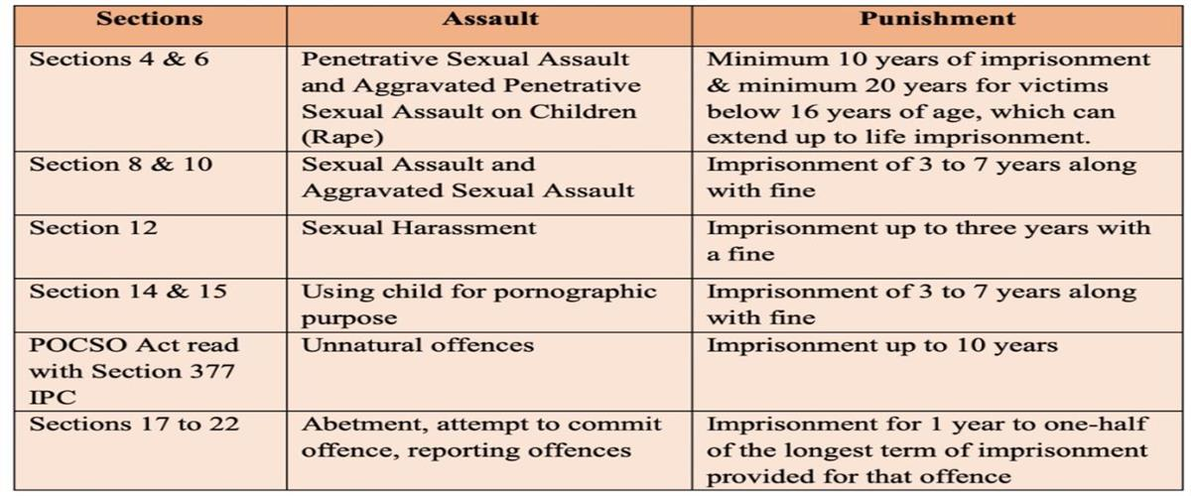
Adv Siddhant Kuwad

Dec 07, 2022 Share :-
The sexual offences which are recognized under the POCSO Act and Punishments for those offences Penetrative and aggravated penetrative sexual assault, sexual and aggravated sexual assault, sexual harassment, and child harassment including using of a child for pornographic purposes are the five offences against children that are covered by this act.
This act envisages punishing even for abetment or for an attempt to commit the offences defined in the act. It recognizes that the intent to commit an offence, even when unsuccessful needs to be penalized. The punishment for the attempt to commit is up to half the punishment prescribed for the commission of the offence and the various penal provisions in the act may be summarised in a tabular form for easy reference as below:-

Description of  offences | Relevant sections  Under POCSO | Minimum  sentence | Maximum sentence
Penetrative sexual Assault | Sec-4 | Seven years | Imprisonment for life
Aggravated Penetrative sexual  assault | Sec-6 | Ten years  (R/I) | Imprisonment for life
Sexual assault | Sec-8 | Three years | Five years
Aggravated sexual  assault | Sec-10 | Five years | Seven years
Sexual harassment | Sec-12 |  | Three years
Using Child for pornographic purposes | Sec -14(1) |  | 5 years & up to 7  years for a subsequent offence
Using Child for pornographic purposes | Sec -14(2) | Ten years | Imprisonment for life
Using Child for pornographic purposes | Sec -14(3) | Rigorous Imprisonment  for life
Using Child for pornographic purposes | Sec -14(4) | Six years | Eight years
Using Child for pornographic purposes | Sec -14(5) | Eight years | Ten years
Storage of  pornographic material involving child | Sec -15 |  | Three years &/or Fine
Abatement of offence | Sec- 17 | Provided for  the offence
Attempt to commit  offence | Sec -18 | Half of the  longest term
Failure to Report or  Record Complaint | Sec-21 |  | 6 Months to 1 year  &/or Fine
False Complaint or  False Information | Sec - 22 |  | 6 Months to 1 year  &/or Fine

Process for Age-Determination under Section 94, Juvenile Justice Act, 2015
