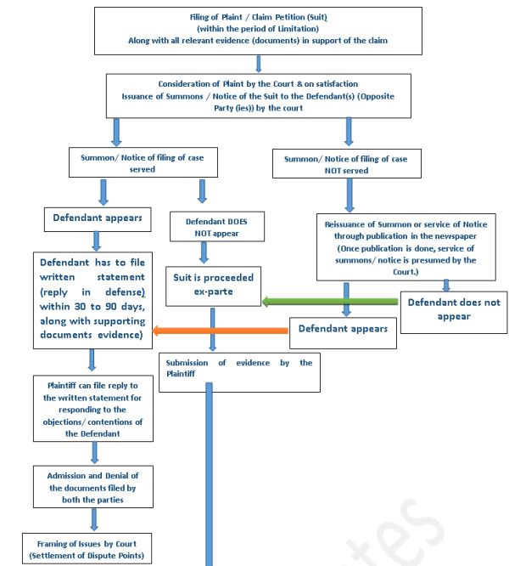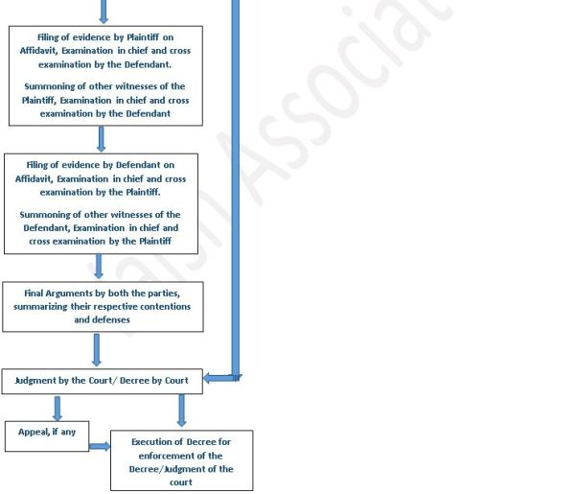

- The process of the trial of a civil case and its different stages is given in the Code of Civil Procedure 1908 (CPC).
- Court may grant time and adjourn hearings, with or without cost (Order XVII CPC).
- The decree and the orders of the Court can be executed through forcible measures by Court under Order XXI of CPC, in which the complete process of the execution has been given.
- The suit can be withdrawn or compromised at any point of time, under Order XXIII of CPC.
- Under Order XXVI, an application may be filed before the Court for appointment of a Commissioner (akin to Anton Pillar Order), for
  - Examination of Witness;
  - Local Investigations;
  - Scientific Investigations;
  - Performance of a ministerial act;
  - Sale of movable or immovable party;
    - At the cost of the party seeking appointment.
The Local Commissioner, appointed by the Court, is considered to be an officer of the Court having all powers, which a Court Officer can exercise.
- Under Order XXXIX of CPC, the Court can pass TEMPORARY INJUNCTION AND INTERLOCUTORY ORDERS, for
  - Preserving the subject-matter of the suit;
  - Preventing the Defendant from removing or disposing of his property;
  - Preventing irreparable loss or injury;
  - Prevent continuation of breach of any right.
* The flow chart may not be exact as per rules, and does not account for all eventualities.

