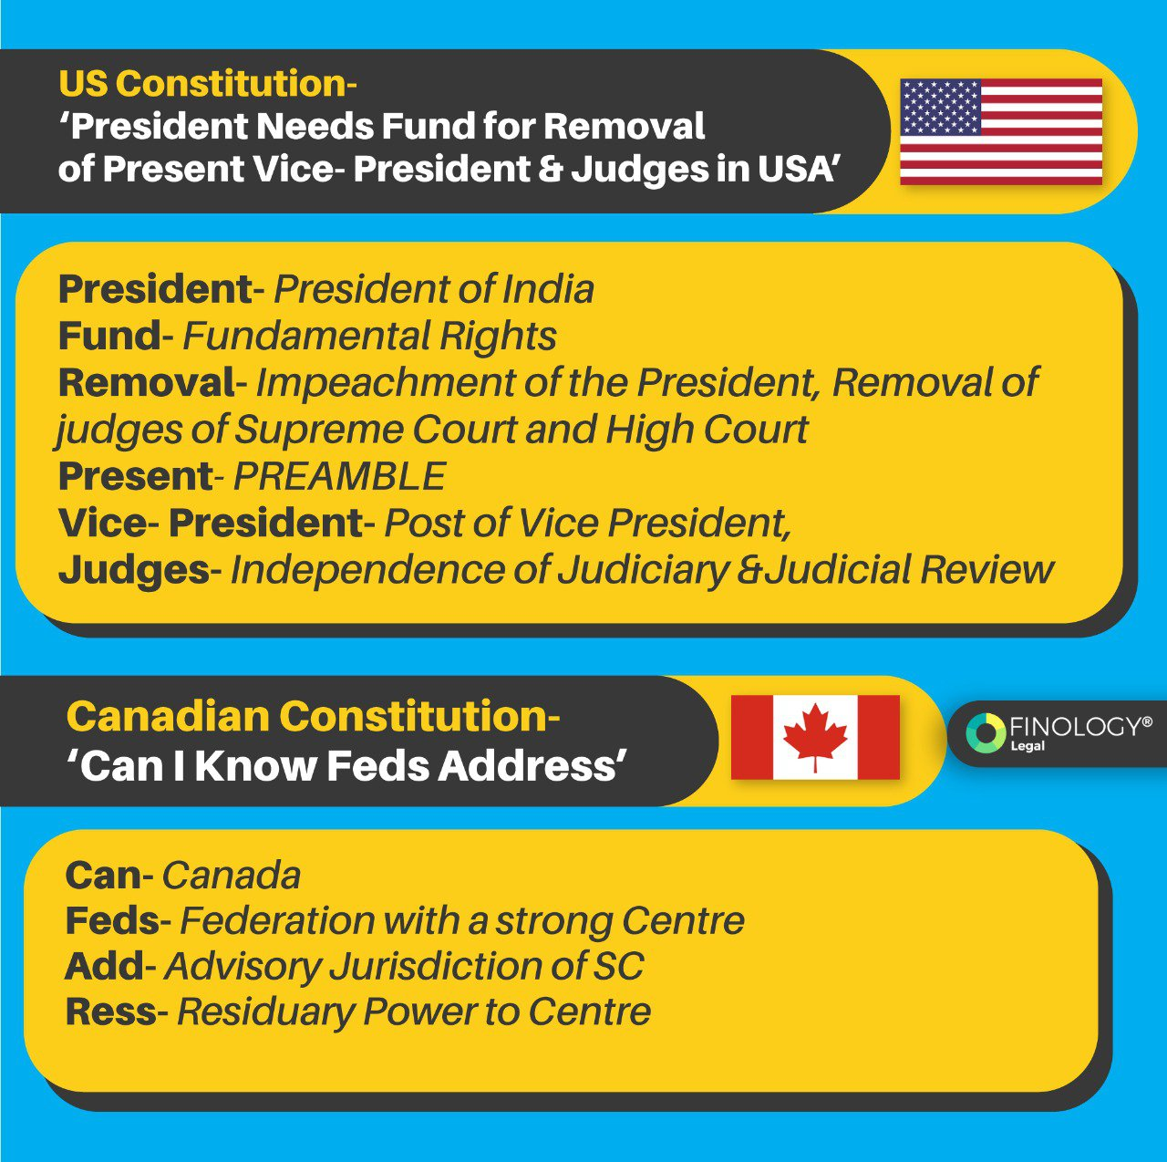How can I memorize the articles of the constitution? What are the easy ways to remember all the Fundamental Rights? What are the tricks to remember Parts of the Constitution? These are some of the question every law student seeks answers for!
The Constitution of India is considered to be one of the lengthiest and most detailed document when compared to other countries. And only the law students will know how difficult a task of remembering 448 articles, 25 parts and 12 schedules is! What if we tell you there are some easy ways to remember all this? So here we will be discussing some tips and tricks to remember the Important Articles, Parts and Schedules of the Constitution.
So starting with the Parts of the Constitution- When the Constitution came into force there were just 22 Parts and now currently we have 25 Parts. We created these short tricks that will help you to remember the Parts of Indian Constitution .
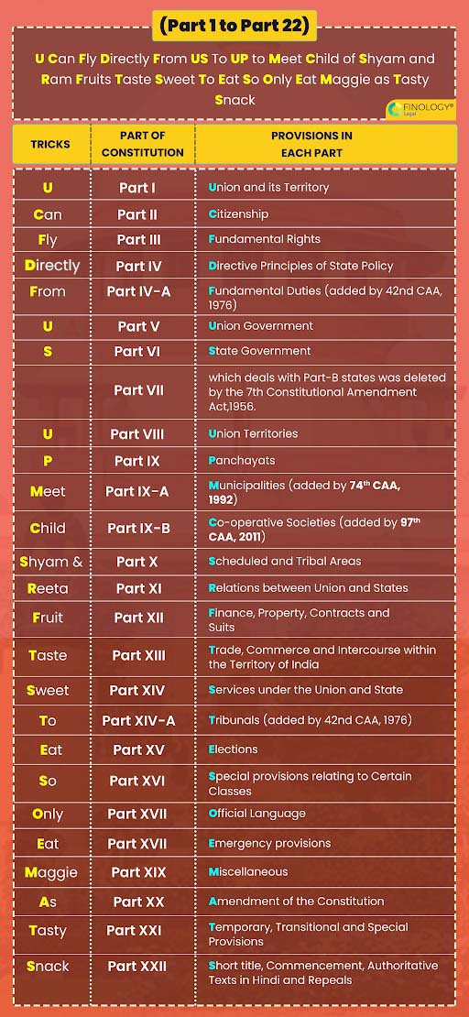

Schedule of the Constitution
Did you know that in the Indian Constitution Schedules helps in categorizing bureaucratic activity and government policy? The government of India Act in 1935 included 10 Schedules in the Constitution and currently there are 12 Schedules in the Constitution.
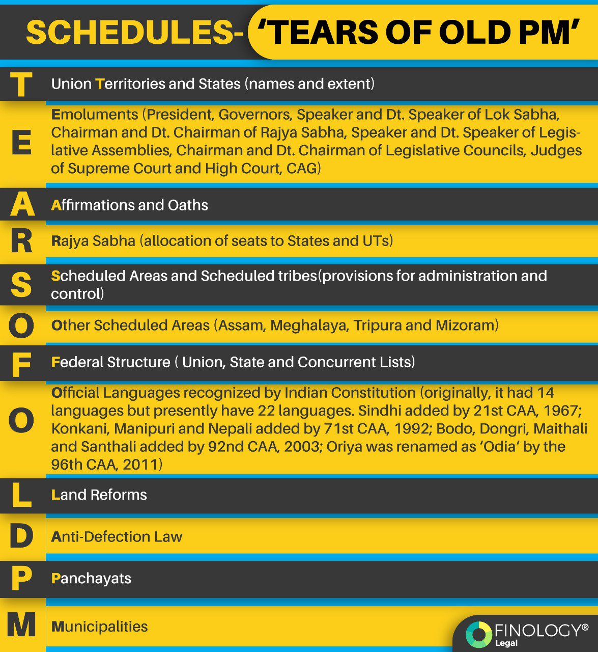
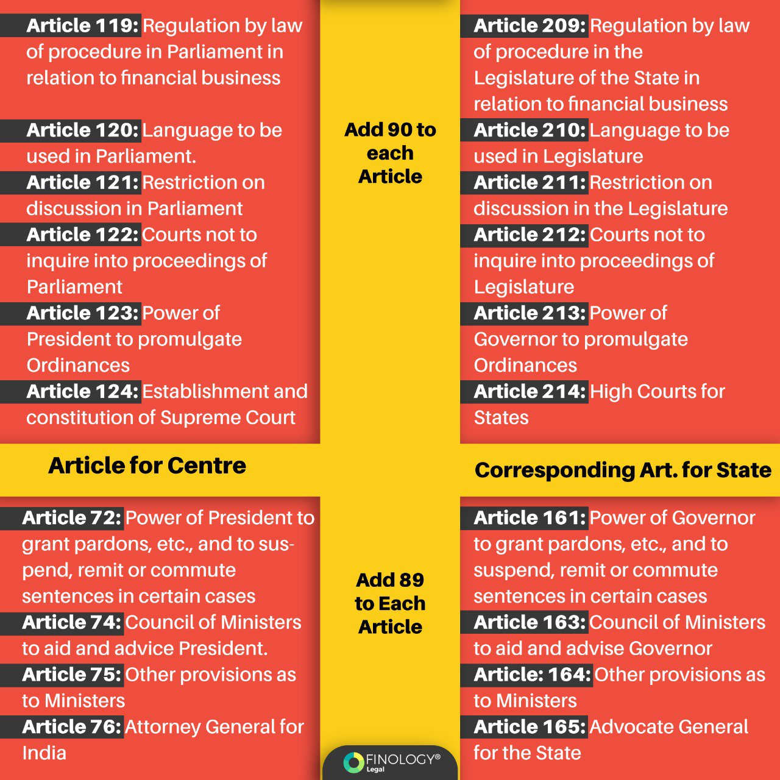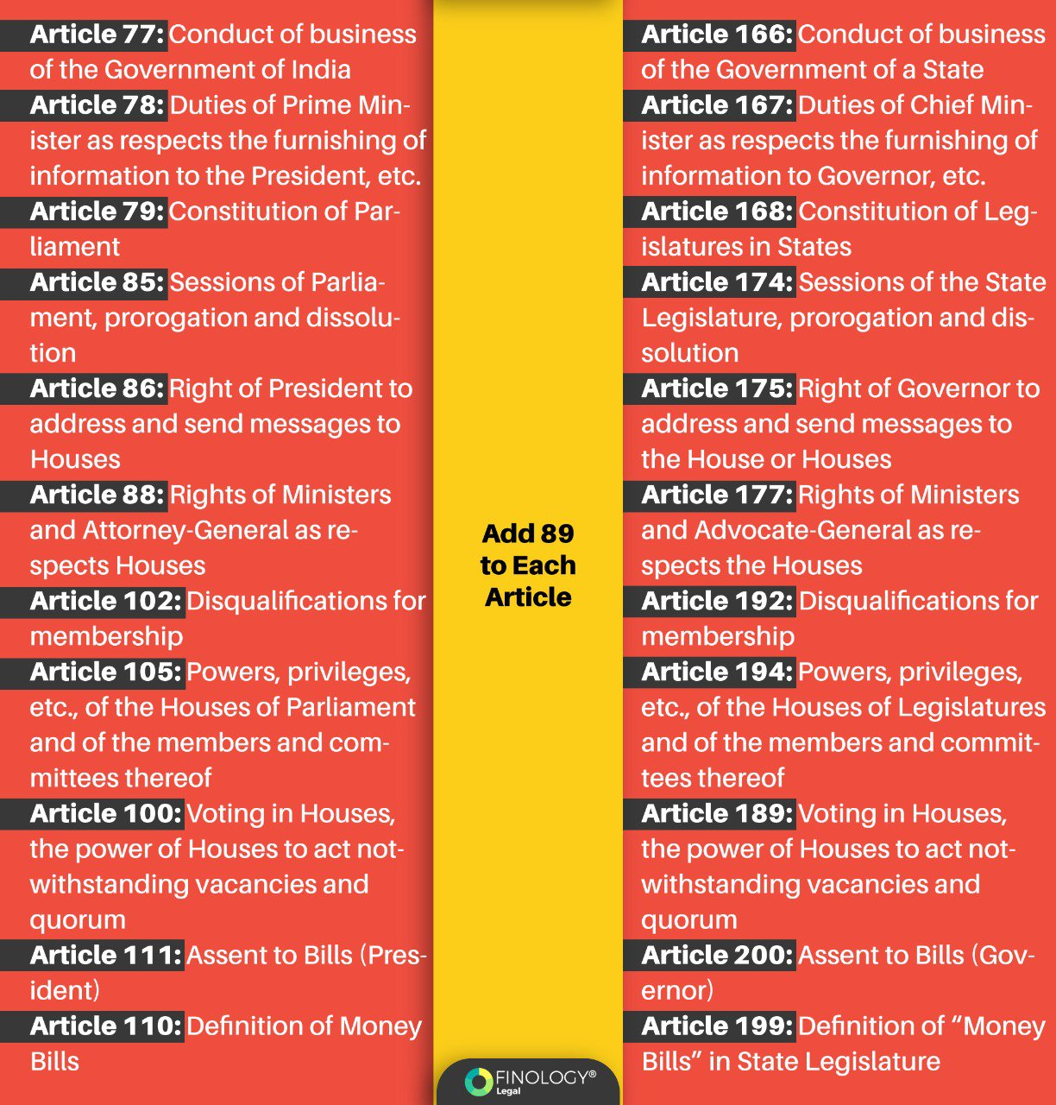

Refer to the below-mentioned on how to remember articles of the Indian Constitution in under 10 minutes.
Trick 1 - Add 4 to all the subsequent articles related to Emergency Provisions.
For instance, 352+4= 356; 356+4=360
- Article 352 – Proclamation of emergency (National Emergency)
- Article 356 – State Emergency (President’s Rule)
- Article 360 – Financial Emergency
Trick 2 - Add 90 to the following articles the Centre and their counterpart articles in the States.
For instance, 112+90=202; 113+90=203; 114+90=204; 115+90=205; 116+90=206, and so on.
Article for Centre are as follows:-
- Article 112: Annual Financial statement for Union
- Article 113: Procedure in Parliament with respect to estimates
- Article 114: Appropriation Bills Article 115: Supplementary, additional, or excess grants
- Article 116: Votes on account, votes of credit, and exceptional grants
- Article 117: Special provisions as to financial Bills
- Article 118: Rules of procedure
Corresponding Articles for States are as follows.
- Article 202: Annual financial statement for State
- Article 203: Procedure in Legislature with respect to estimates
- Article 204: Appropriation Bills Article 205: Supplementary, additional, or excess grants
- Article 206: Votes on account, votes of credit, and exceptional grants
- Article 207: Special provisions as to financial Bills
- Article 208: Rules of procedure
Trick 3: For remembering the Articles of the Constitution is " Lazy Elephants Jump Slowly And Sit Regularly."
- L = legislative.
- E = executive.
- J = judicial.
- S = states.
- A = amendment process.
- S = supremacy of constitution.
- R = ratification.
Trick 4 - Remember the articles of the Center, and add 89 to their corresponding articles in the state.
For instance, 72+89=161; 74+89=163; 75+89=164; 76+89=165, and so on.
Article for Centre are as follows:-
- Article 72: Power of President to grant pardons, etc., and suspend, remit, or commute sentences in certain cases
- Article 74: Council of Ministers to aid and advise President.
- Article 75: Other provisions as to Ministers
- Article 76: Attorney General for India
- Article 77: Conduct of business of the Government of India
- Article 78: Duties of Prime Minister as respects the furnishing of information to the President, etc.
- Article 79: Constitution of Parliament
- Article 85: Sessions of Parlia ment, prorogation and dissolu tion
- Article 86: Right of President to address and send messages to Houses
- Article 88: Rights of Ministers and Attorno
Corresponding Articles for States are as follows.
- Article: 164: Other provisions as to Ministers
- Article 165: Advocate General for the State
- Article 166: Conduct of business of the Government of a State
- Article 167: Duties of Chief Minister as respects the furnishing of information to Governor, etc.
- Article 168: Constitution of Legislatures in States
- Article 174: Sessions of the State Legislature, prorogation and dissolution
- Article 175: Right of Governor to address and send messages to the House or Houses
- Article 177: Rights of Ministers
Trick 5 - India has three union executives, including the President, Vice President, and the Union council of ministers headed by the Prime Minister. The best tricks to remember articles of the Indian constitution article to note the sequence of articles. The pattern of the unit-digit numbers is 2,3,4. And the pattern of tens digit places is 5, 6, and 7, respectively. The articles are article 52, article 63, and article 74. Add 89 in 74; it will become 163, that is, the article of the state council of ministers headed by the chief minister.
Trick 6 - Article 102 mentions the disqualification of members of parliament. If you add 89 to 102, it will result in 191. Article 191 talks about the disqualification of MLAs. In most cases, you can use 89 to learn articles of the Indian Constitution.
Trick 7 - Mnemonics in the laws regarding fundamental rights. Let’s learn it through an example –
"Law removes all doubt,” the word law comes in article 14,
D stands for discrimination
O stands for an opportunity in public employment
U stands for untouchability
T stands for titles.
Article 15 talks about no discrimination, article 16 says equal opportunity in public employment, article 17 stands for untouchability, and article 18 says abolition of titles.
As said above, there are 25 parts of the Indian Constitution. Following are some of the simple mnemonics that can easily help you remember all the parts of the constitution. Read the following mnemonic on how to remember parts of the Indian constitution.
Mnemonic 1: U Can Fly Directly From US to UP to Meet Child of Shyam and Ram; Fruits Taste Sweet To Eat So Only Eat Maggi As Tasty Snack (to remember all 25 parts)
Mnemonic 2: Read From the Start to End Please (from part XI to part XVI)
Mnemonic 3: LEMATS (from part XVII to part XXII)

Tips and Tricks to Remember the Constitution of India in under 10 minutes
Here are a few practical tips and tricks through which you can remember the Indian Constitution within 10 minutes.
Constitution – A breathing document!
The Constitution is not a book; it is a breathing document. It is a living document that reacts and responds to every changing scenario in a country.
The Constitution is not a collection of articles or words, whereas every word in the constitution matters and has its significance.
The Constitution has its schematics. It means that the Constitution is engaging with you, and you’re engaging with the Constitution.
For example, if you give a mobile phone to anyone in the world who does not understand its functioning, for him, a mobile phone is of no use. Whereas, if you hand it over to someone who understands how to use it, he can use it in a million ways.
Similarly, it is essential to understand the schematics of the Constitution. It includes why there was only this number of articles in part 1, part 2, etc.
There are specific fixed designs. It includes union executive and union state relations.
Three union executives
There are mainly three union executives in the country, including the President, Vice President, and the Union council of ministers headed by the Prime Minister. The best way to learn their article is 2,3,4, followed by 5, 6, and 7, respectively. Hence article 52, article 63, and article 74. Adding 89 in 74 will become the state council of ministers headed by the chief minister.
Article 72 of the Constitution gives mercy power to the president. Similarly, mercy powers are given to the governor. Adding 89 to 72 is article 161.
Article 102 talks about the disqualification of members of parliament. Adding 89 to 102 is disqualification of MLAs. In most cases, you can use 89 to learn about articles in the Indian Constitution.
Try to read from politics to the polity. On 12th June 1975, a judgement was passed by the Allahabad high court against Indra Gandhi. According to the decision, Mrs. Gandhi has done electoral misconduct.
During this time, Jayshankar Narayan built a Bihar Chatra Sangharsh Samiti, where 5-7 lakh students from Bihar gathered in Delhi and came to roads to protest against Mrs. Gandhi. To avoid such conditions, she decided to impose an internal emergency in the name of internal disturbance.
Soon after this, the government of Muraji Desai came to power. He introduced the 44th constitutional act 1975. The first step he made was eliminating the word-internal disturbance from the Constitution and changing it into armed rebellion.
Logic in the Constitution of India
There is a logic in the Constitution in India.
Part 3 of the Indian Constitution deals with the fundamental rights, whereas part 4 deals with DPSP. in part 3, the Constitution gives guaranteed rights against the state. Whereas part 4 is a direction given to the state for the individual. Part 3 starts from article 12 to article 35, and part 4 begins from articles 36 to 51.
The first article of part 3 and part 4 defines the state in the same way.
Similar to medical, there are specific Mnemonics in the laws regarding fundamental rights. Let’s learn it through an example –
Law removes all doubt”, the word law comes in article 14, D stands for discrimination, O stands for an opportunity in pubic employment, U is untouchability, and T is titles. Article 15 talks about no discrimination, article 16 says equal opportunity in public employment, article 17 stands for untouchability, and article 18 says abolition of titles.
In summary, associated memory is formulated. To complete this, you need to watch the news or current affairs. For example – there is no such right as the right to marry. In 2019, there was such a question. Note, it was a trick question whose answer was article 21. Right to marry means the freedom to marry anyone. It also includes life living with choice and dignity.
The logic of the Constitution, such as the triple talaq case where two women of the same community were treated differently. It is a violation of article 14.
Remember schematics. In the union executive, the president is described as the first, followed by the vice president and the union council of ministers.
Lastly, the Constitution of India is an extreme power in itself. Learn how the Constitution can be used for the benefit of the people.
Conclusion
We come to the end of the topic on Tips and Tricks to Remember the Constitution of India in under 10 minutes. Today, we discussed practical study tips and tricks on how you can understand, learn, and remember the entire Constitution of India, which is one of the most important aspects of your UPSC exam and life. Every UPSC aspirant finds it difficult to untangle the ways to learn the Constitution; however, in this article, we discussed how to remember the Constitution of India in under 10 minutes.
Apart from these tips, a great strategy and taking up regular mocks, going through Constitution can genuinely contribute to your success. Before sitting for the exam:
Make sure you’re well-prepared with all questions related to the topic because all questions are essential if you’re to become the topper.
Pick the right books and courses because they can significantly change your journey to become a topper. Once you have the right mix of books, it can help.
In addition, keep these hacks handy as they are indispensable.

